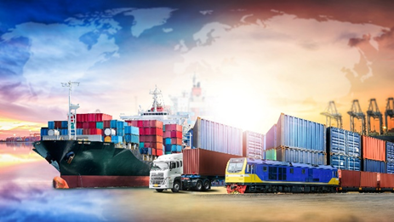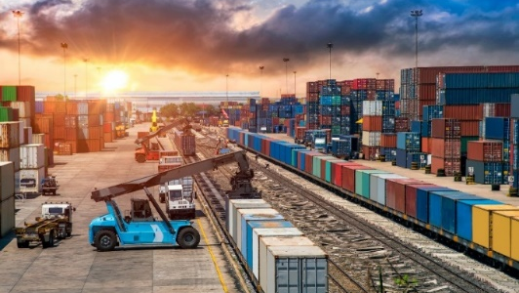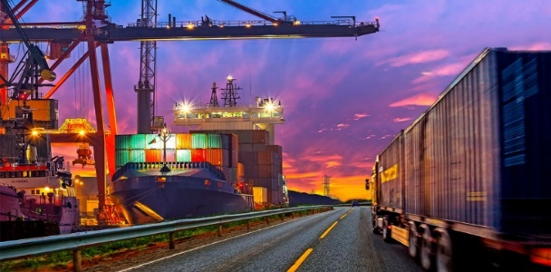
TRANSTEC 16th International Transport Corridors Forum will take place in Saint Petersburg on September 21-24, 2021 at Expoforum CEC.

We look forward to welcoming you at the Forum opening ceremony to be held on September 22 at 10.15 a.m. The ceremony will be attended by Dmitry Zverev, State Secretary – Deputy Minister of Transport of the Russian Federation, Sergey Kharlashkin, Deputy Chairman of the Government of Leningrad Region for Transport and Fuel and Energy Complex, Uldis Reimanis, Deputy State Secretary of the Ministry of Transport of Latvia, doctor Kazem Jalali, Ambassador Extraordinary and Plenipotentiary of the Islamic Republic of Iran in the Russian Federation and Sergey G. Voronkov, the General Director of Expoforum-International LLC.

TRANSTEC has been held in Saint Petersburg since 1994. In 2021, Autonomous Non-Commercial Organisation Directorate of international transport corridors (ANO DITC) acts as the forum co-organiser. The Ministry of Transport of Russia together with ANO DITC provide official support to the forum and are included into the programme committee thereof for shaping the relevant agenda of the business programme.

The forum is held under the sponsorship of the Government of Saint Petersburg, Maritime Board under the RF Government, Federal Agency for Maritime and River Transport of Russia, International Coordinating Council for Trans-Eurasian Transportation, Association of Commercial Seaports, Admiral Makarov State University of Maritime and Inland Shipping, Russian Road Scientific Research Institute and National Union of Transport and Logistics Experts.

Over 400 delegates and speakers from Russia, Finland, Holland, Germany, Turkey, Iran, Mongolia, China, Kazakhstan and Azerbaijan have confirmed their participation in TRANSTEC 2021 forum.

Over 10 round-table discussions and sessions are planned to be held within the forum. Besides, this year, an exhibition display is organised along with the business programme. DITC and the Embassy of Latvia are among the largest exhibitors.

The key subject of 2021 forum is transport corridors in Eurasian space and inter-state cooperation.

On September 21, the first forum day, the discussions will focus on the trends of the global container system, the issues of inland water transport development and on the key aspects of customs logistics.

In the course of the session “Global Container System: State and Trends”, the experts will discuss the present-day state and challenges of the global transport container system, the development trends in maritime and land freight distribution container subsystem, the issues of container re-handling equipment development, prospects and issues of the Russian container transport system, digitalisation opportunities in the container business and other relevant subjects. The representatives of USC, Yanino logistics terminal, KONE CRANES Finland, Institute of International Transport Management of Admiral Makarov State University of Maritime and Inland Shipping, LENMORNIIPROJECT and of other relevant organisations are invited to take part in the session.

The participants of the session “Inland Water Transport: Development of the Inland Waterways Network” will discuss the national project “Inland Water Transport Development”, prerequisites and factors promoting freight traffic on inland waterways of Russia, infrastructure issues of IWW, technical state of the river ports and prospects of implementing infrastructure projects. Among the experts invited are the representatives of the Ministry of Transport of Russia, Federal Agency for Maritime and River Transport, Ministry of Transport and Road Industry of the Republic of the Sakha (Yakutia), Russian Chamber of Shipping, USC, “Volga Shipping” and of other companies specialising in river transportation.

The round-table discussion “Customs Logistics and Supply Chains Management” will be devoted to the improvement of competitiveness of national ITCs due to simplification of the customs procedures. The participants will share their views on the role and tasks of customs services, will share the experience of interacting with the customs services of European Union countries, and will estimate the performance prospects of the Institute of Authorised Economic Operators in EAEU. The representatives of IRU in Eurasia, Baltic Customs of the Federal Customs Service of Russia, United Transport and Logistics Company – Eurasian Rail Alliance (UTLC ERA), Russian-Asian Union of Industrialists and Entrepreneurs, AEB Committee for Customs and Transport and other experts have been invited to take part in the discussion.

On September 22, the second forum day, the issues relating to the interstate cooperation in Eurasian space, transit in the Arctic, digitalisation and port logistics will be raised.

The subject of the kick-off meeting is “Transport Corridors in Eurasian Space: Interstate Cooperation”. The subject relevance is attributable to changes on the logistics market in the period of pandemic. The visiting experts will discuss the global economy tendencies and the effect thereof on the trading routes, priority objectives for unlocking the transit potential of the international transport corridors, the ways to enhance economic attractiveness and prospect of the North-South corridor, the issues of transport policy coordination within the ITC and the railways and ports interaction formats. The representatives of the Ministry of Transport of Russia, Embassy of the Islamic Republic of Iran in RF, Latvian Railway, the Ministry of Foreign Affairs of Mongolia, VR Group (Finland), RZD OJSC, SC Rosatom, UTLC ERA, Government of Leningrad Region and other Russian regions have been invited to take part in the meeting.

The Arctic subject that was chosen as one of the priorities of the TRANSTEC 2021 business programme will be represented by the session “International, Technical and Scientific Cooperation to Ensure Stable Shipping and Transit Development in the Arctic”. The first session block will focus on the opportunities for the shipbuilding industry to support new projects and enhance the efficiency of shipping in the Arctic. The experts will discuss the latest global and Russian tendencies in shipbuilding and designing for the Arctic, state support measures and financial instruments for the development of the Arctic shipbuilding, technologies and solutions to safeguard shipping under Arctic conditions, the prospects of the fleet renewal and using unmanned and autonomous vessels on the NSR. The reports will be delivered by the representatives of the Ministry of Industry and Trade of Russia, Ministry for the Development of the Far East and the Arctic, Northern Sea Route Directorate of SC Rosatom, Atomflot, USC, NOVATEK, Norilsk Nickel, Zvezda Shipbuilding Complex, Krylov State Research Centre and of other specialised enterprises. The second session block will be devoted to the development of shipping on the Northern Sea Route and prospects of NSR as the international transit corridor. The session participants are expected to be addressed by the representatives of the State Commission for the Arctic Development Issues, Sovcomflot, the Russian Chamber of Shipping, Northern Sea Transit Corridor Project Office, Corporation for Development of the Russian Far East and the Arctic, Gazprom neft, FESCO and of other companies operating in the Arctic zone.

The National Union of Transport and Logistics Experts acts as a partner of the session “Digital Logistics Ecosystem”. The participants will discuss digital transport corridors in the EAEU digital agenda and the infrastructure of digital transport corridors. The representatives of Hamburg Port Consulting (Hamburg), SC Optimalog, Federal Autonomous Institution ROSDORNII, RZD Logistic, Centre for Development of Digital Platforms, GLONASS, Digital Transport Era Association and of Digital Solutions of Regions will take part in the discussion.

The partner of the session “Ports and Marine Logistics” is the Association of Marine Commercial Ports. The issues related to implementation of infrastructural sea transport projects in the framework of the updated CPMI, port hubs of international significance, industrial port zones of full logistics, prospects of including minor ports in international sea traffic and other relevant aspects will be proposed for consideration. The representatives of Port of Algeciras (Spain), Port of Antwerp (Belgium), Port of Hamburg (Germany), Corporation for Development of the Russian Far East and the Arctic, RZD-Invest, Primorsky General Transhipment Terminal, OTEKO, Administration of sea ports of the Baltic Sea and of other organisations have been invited to take part in the session activities.

During the round-table discussion “Implementation of the Project of Multimodal Transport and Logistic, Engineering and Manufacturing Cluster of the Northwest Region”, the concept of establishing Baltiysky International Transport and Logistic Centre as one of the basic elements of mega project “United Eurasia: RAZVITIE Trans-Eurasian Belt” will be considered.

On September 23, the third forum day, the development prospects of the North-South ITC, investments in the transport infrastructure and railway transit will be discussed.

The session devoted to North-South ITC will touch upon the issues of Caspian logistics optimisation, the role of Chabahar free zone and Enzeli free commercial and industrial zone in the corridor development, and the prospects of establishing multimodal transport and logistic centres in the key foreign ports included into the ITC. The representatives of Caspian International North-South Integration Club, joint Iran-Russian Chamber of Commerce and Industry, international working group on North-South ITC development, International Organisation of Northern Regions “Northern Forum”, VEB RF, Eurasian High Technologies Centre and other experts will take part in the discussion.

Session “Construction and Upgrading of RF Transport Infrastructure. Investments and Legislation” will focus on the discussion of state supporting measures to the industry, specifics of the off-budget fund-raising for the infrastructure projects, forms of the infrastructure projects implementation, methods and models of assessing the impact of transport projects on the economic development and of other financial and legislative issues. Among the visiting experts are the representatives of Rosmorport, InfraVEB, RZD-Invest, Agency of Economic Development of Leningrad Region.

RZD-Partner business magazine acts as a partner of the “Railway Transit” session. The issues regarding development of railway transportation routes in the restructured Comprehensive Infrastructure Modernisation and Development Plan, unlocking the transit potential of Russian railways, construction of high-speed networks, interaction of railways and sea ports, as well as regarding implementation of new information technologies will be proposed for discussion. The session will be attended by the representatives of UTLC ERA, LDZ Logistika, RZD Logistics and other companies.

Business negotiations of the market players with signing of partnership agreements will also be held in the framework of the forum. In particular, in order to renew Yakutia passenger fleet with the hydrofoil vessels, the Ministry of Transport and Road Industry of the Republic of Sakha (Yakutia) is planning to sign a Cooperation Agreement with the Ministry of Industry and Trade of Russia and with JSC Alekseev`s Hydrofoil Design Bureau.

Expoforum CEC and the exhibition organiser NEVA-International Ltd. have a QR-code with the Safe Travels SPb symbol, confirming the safety of the events and their compliance with the conditions stipulated by Rospotrebnadzor.
NEVA-International Ltd. and the forum partners wish all participants much productive work at the TRANSTEC event!
TRANSTEC forum venue: St. Petersburg, 64/1 Peterburgskoye Shosse, Expoforum CEC
Organiser: NEVA-International Ltd.
Venue Operator: Expoforum-International LLC

